**Chapter 7:**

Introducing JSON

## What Is JSON?

- JSON (JavaScript Object Notation) is a language-independent data format that expresses JSON objects as human-readable lists of properties.

- JSON is commonly used in asynchronous browser/server.

- JSON isn’t a proper subset of JavaScript.

## JSON Syntax

- The JSON presents a JSON object as a brace-delimited and comma-separated list of properties.

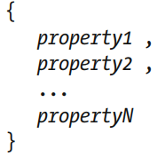

- JSON supports six datatypes: *Number, String, Boolean, Array, Object, Null.*

- Example:

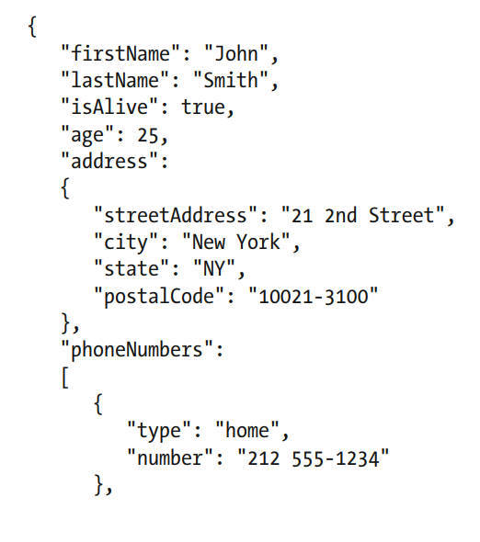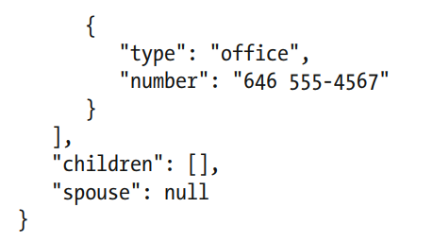

- JSON objects are stored in files with the .json file extension.

## Validating JSON Objects

- JSON Schema expresses a schema as a JSON object.

- Advantages of JSON Schema:

+ It describes your existing data format.

+ If offers clear, human-readable, and machine-readable documentation.

+ It provides complete structural validation, which is useful for automated testing and validating client-submitted data

- The JSON Schema web site focuses on draft version 4 of the JSON Schema specification. This specification is divided into three parts: JSON Schema Core, JSON Schema Validation, and JSON Hyper-Schema.

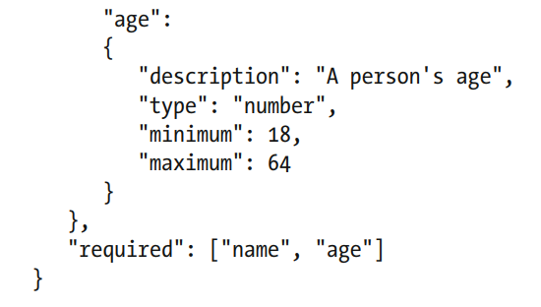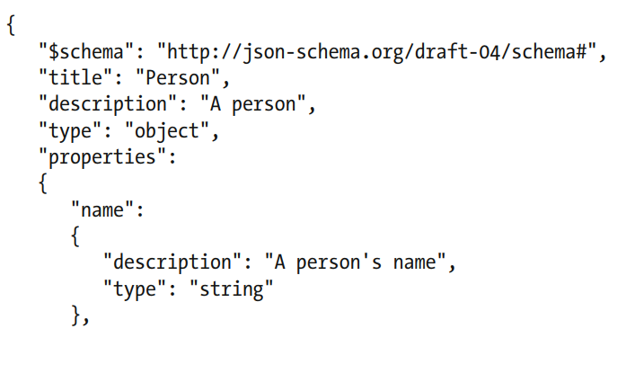

$schema: draft version 4 specification.

title: JSON object being validated by this schema.

description: description of object.

type: type of object.

properties: array of object and their characteristic.

required: contains element must be in object.